BOOKS - Getting Personal with Your Finances

Video: https://www.entrepreneurship.org/learning-paths/startup-ceo/getting-personal-with-your-finances
Getting Personal with Your Finances
Just because you understand the literal difference between a $500 expense and a $700 expense doesn’t mean you viscerally understand the difference between a $500,000 expense and a $700,000 expense. It takes a while to hone your instincts around these things.
Suggested Readings
Founders School || Startup CEO || Getting Personal with Your Finances || Impact Guide (PDF).
Blumberg, Matt and Hanny Hindi. “Chapter Nineteen: Making Sure There’s Enough Money in the Bank.” Startup CEO: A Field Guide to Scaling up Your Business. Wiley, 2013. 159-164. Print.
Blumberg, Matt and Hanny Hindi. “Chapter Twenty-Two: Forecasting and Budgeting.” Startup CEO: A Field Guide to Scaling up Your Business. Wiley, 2013. 181-188. Print.
Dobbs, Richard and Bill Huyett and Tim Koller. “The CEO’s Guide to Corporate Finance” McKinsey Quarterly, November 2010.
Franklin, Joyce L. Startup Wealth: The Entrepreneur's Guide to Personal Financial Success and Long-term Security. Rubydon, 2014.
“Financial Foundations: Your Balance Sheet” – The Art of Startup Finance with Bill Reichert.
“Financial Processes: Income Statement” – The Art of Startup Finance with Bill Reichert.
“Financial Budgeting: Your Long-Term Forecast” – The Art of Startup Finance with Bill Reichert.
Questions for You
How do I remain hands-on with the financials of the business?
What events or milestones will change my costs and revenues?
Are there similar companies that have gone down a similar path? Can we compare their experience with our plans for the future?
What are the main drivers of my revenues and costs?
Questions for Your Team
How can we improve our cash flow?
Are we managing our receivables and payables as efficiently as possible?
How can we improve the profitability of our business model?
Where is the most leverage to improve our profitability?
Tools and Exercises
Create a management dashboard for your key performance metrics in "Financial Monitoring: Your Performance Metrics” with Bill Reichert
Next in this series
Funding Growth
You may also be interested in…


Startup CEO
Matt Blumberg, founder and CEO, coaches entrepreneurs through the crucial transitions that turn a startup into a sustainable business and a founder into a CEO.
Video|01:46to watch
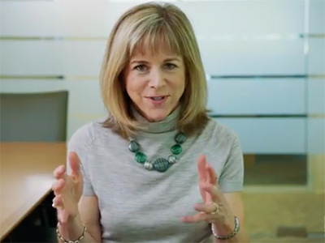

Scaling Your Company
Rory O’Driscoll and Kate Mitchell, partners at Scale Venture Partners, will explain how scaling differs from the startup phase, what kind of metrics you’ll need as you accelerate and what kind of team you’ll need.
Video|02:27to watch

Aus <https://www.entrepreneurship.org/videos/startup-ceo/getting-personal-with-your-finances>

